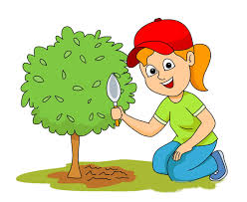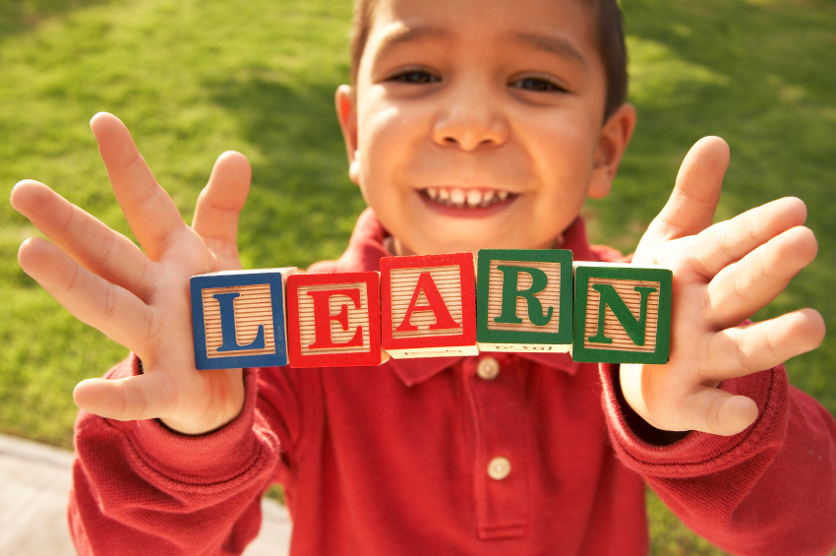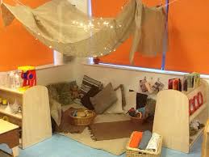 

**Pupil Voice**

* We are going to encourage everyone to be involved in making decisions about learning.
* The JLT will help to improve the school and promote pupil voice.
* We will get more opportunities to talk about our learning.
* Adults in school will ask us about our learning and listen to what we say.

**Health and Wellbeing**

* We want to make sure everyone feels safe and happy at school.
* We will develop cosy corners in every classroom and in the nursery.

**Numeracy**

* We aim to make sure everyone is making better progress in maths.
* Teachers will receive training so that maths continues to be exciting and fun.
* We will be given tasks that challenge us.
* We will use a variety of resources to help us with our learning.

**Learning and Teaching**

* We are all going to be challenged so that we make good progress.
* Teachers and support staff will help us to understand what and why we are learning and how we can use what we have learned.
* We will be involved in planning our learning.
* We are going to use feedback to improve our learning.

**Outdoor Learning**

* We will develop the playground to make it a creative learning space.
* We will be given more opportunities to learn outside.

**The World of Work**

* We will learn about a range of jobs and the skills required for them.
* We will develop partnerships with parents and local businesses.

**Child Friendly School Improvement Plan 2018**

**What are we doing to improve our school?**